Description: Beskrivning: hd_vertikal_farg WORD.wmf

Thesis report

Master thesis in Microdata Analysis

Business Intelligence Program

School for Technology and Business Studies

Dalarna University

Description: StreckTiteln

All for one one for All

Author: Bamshad Shirmohammadi

Supervisor: Professor Arend Hintze

Examiner:

Dalarna University

791 88 Falun

Sweden

Tel 023-77 80 00

Subject:

Course code: MI4002

Points: 15/30hp

Date of the examination: 20XX-XX-XX

**Abstract**

**Contents**

[Introduction 1](#_Toc58580367)

[Background 1](#_Toc58580368)

[Purpose 2](#_Toc58580369)

[Literature review 2](#_Toc58580370)

[Material and Methods 2](#_Toc58580371)

[Experiments 3](#_Toc58580372)

[Data description 4](#_Toc58580373)

[LOD.csv 4](#_Toc58580374)

[Movement.csv 4](#_Toc58580375)

[Beep.csv 5](#_Toc58580376)

[Methods 5](#_Toc58580377)

[LOD analyzer 5](#_Toc58580378)

[Movement analyzer 6](#_Toc58580379)

[Beep analyzer 8](#_Toc58580380)

[Results 8](#_Toc58580381)

[Score variations through generations (Based on LOD files) 8](#_Toc58580382)

[Overall score statistics (Based on LOD files) 9](#_Toc58580383)

[Clone versus not clone statistics (Based on LOD files) 9](#_Toc58580384)

[Behavioral statistics (Based on movement files) 11](#_Toc58580385)

[Beep versus mute statistics (based on beep files) 12](#_Toc58580386)

[Discussion 13](#_Toc58580387)

[Conclusions 13](#_Toc58580388)

[References 13](#_Toc58580389)

# Introduction

The state of the art machine learning technique to optimize neural network AI controllers (agents) is back-propagation and deep learning. This method assumes that solutions and examples for such solutions are known. A different approach to this is evolutionary computation and genetic algorithms. Instead of rewarding proper responses to specific situations and hoping for proper generalization, a genetic algorithm uses an objective function. This objective function evaluates the total performance of a system and can select controllers that perform better. Over many generations such system optimizes controllers, often finds more creative solutions [1], and most importantly does not require knowledge about specific actions but only the desired outcome. This method works well when optimizing individual controllers as their objectives do not conflict with the objectives of other controllers. When agents need to interact or work in teams [2], the situation becomes much more complicated, and often the goals of the individual are contrary to the success of the group. Imagine self driving cars. Optimizing them to reach their goal as fast as possible might induce negative side effects. How to overcome such issues? Group level selection plays an important role in evolution. Often individuals do not act alone, but in groups. As such they can achieve together more than alone. Collaborative hunting is one of those examples, where individuals are not selected individually but as a group [3]. This group level selection scheme typically pools the resources the group collected and redistributes them back equally, which implies that groups are evaluated by their average performance. What if this scheme is altered? Imagine a group is rewarded according to the performance of its best individual (all for one) or its worst performer (one for all)? In the all for one case, you would pool all resources on one individual, and in the case of the one for all you would distribute the resources as fairly as possible. The big question is, which of the two groups collected the most resources in total? This research will use neuro-evolution where agents are simulated in a virtual environment and controlled by so called Markov Brains. Group level selection regimes such as the ones described above will be tested with respect to their effect on individual and group level performance.

## Background

The people's collaboration in societies can be considered one of the main aspects of the development in terms of economy, health, education, etc. For example, in a country, the citizens would have a better health care system if they pay their taxes; however, it is always possible that some people bypass the rules and stop paying them.

To study this problem, some practices simulate societies using small groups of men and women and test their collaboration methods. One of these experimental economics is the "public goods game." In this game, the participants are given equal amounts of money and a public pot that they can put some or all their money. When they put their tokens in the pot, it will be multiplied by a factor, and then, it will be divided among the players. Considering the game rules, a player who is careful about the social benefits; will put more money, and those who are selfish and only consider their personal benefits will not put anything. The scenario that individuals only think about their gain is called "Tragedy of the Commons," and we would like to find a solution for this absolute tragedy.

Now the main question is how we can force people to be collaborative? In other words, how we can avoid the tragedy of the commons?

If we see it from a government perspective, we would consider incentives to motivate people for a better group working and punishments to avoid selfish approaches. If we look at the issue from a broader perspective covering history, evolution with its group selection mechanism will be our answer. To discuss how natural selection is the solution for the collaboration problem, let's first examine how we humans in agriculture select the best genes for reproduction. In this example, a farmer, based on their criteria (such as the biggest fruits) specifies the desired ones for regeneration.



First Generation

Second Generation

Third Generation



Figure . Human selection

In the above picture, the farmer will have only big ones in the last generation by choosing only the biggest cabbage for reproducing. Nature does the same to all the creators and only let some of them survive through history, and the rest will become extinct.

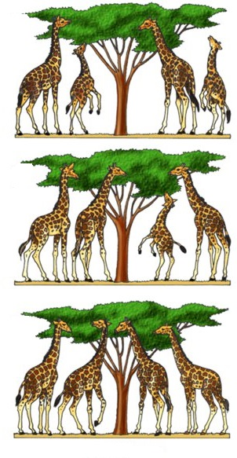

First Generation

Second Generation



Third Generation

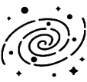

Figure . Natural selection

So, nature acts as the farmer and lets only the tall giraffes survive and produce offspring, and we call it *natural selection*. In the context of natural selection, the individuals' ability to survive and reproduce is called *fitness (w).* You may ask how it comes that we have even a variety of shapes and colors in different species because, if we adapt ourselves based on nature requirements, all of us should look like each other? The answer lies with the two main concepts of mutation and survival. Mutation means sudden and significant changes in the species genetics that makes very different offspring from their parents. Suppose we take a family of giraffes and divide them into two distinct islands which one of them has tall trees, and the other has short trees. If there were no mutation in nature, regardless of the islands' differences, the giraffes after generations would not be different while both groups are from the same family. The mutation causes significantly taller and shorter offspring in the two groups. In the short tree island, the smaller ones will survive and reproduce, and the opposite happens on the other island. Eventually, after a long time by natural selection and mutation, we will have two types of giraffes (short and tall) from the same routes. When we talk about routes in the context of natural selection, we refer to it as an *inheritance*. Darwin's *evolution* is a mechanism composed of inheritance, variation (random mutation), and selection. It leads to an adaptation of organisms that fit their environment better.

So far, we have discussed the concept of evolution, but how does it related to the enhancement of collaboration? Indeed our survival not only depends on our performance but also depends on our team working skills. For instance, ants are so small and weak, but today they have one of the world's most significant populations, whereas strong tigers are in danger of becoming extinct because ants are more collaborative. This type of selection gives survival permission to those who are collaborative, called group selection.

In this study, we will discuss the collaboration problem in Artificial Intelligence (AI). We use an evolvable type of AI, and therefore, we will have the concept of evolution with its three main dimensions (Inheritance, variation, and selection). This research is a step in a chain of works that are focused on a particular evolvable neural network called Markov Brain (which laboratory or university?).

## Purpose

This research seeks to improve the way we train groups of AI controllers (agents) to perform better individually and in teams at the same time. While this is a basic research question in optimization of neural networks using genetic algorithms, it has direct applications to robotics and other autonomous AI decision making systems that need to work in groups.

As we explained in the introduction section, the thesis is in the sequence of other works using Markov's brain. Based on our literature review on other works in this chain of researches and also the other similar studies, we decided to work on the impact of incentives or rewarding schemes on team working of the AI controllers. According to our literature review, this particular area's *research gap* is working on the *minimum* and *maximum* rewarding plans.

## Literature review

# Material and Methods

This research will use the MABE (C++ Modular Agent Based Evolution Framework [4]) to implement virtual test environments. Agents are controlled using Markov Brains [5] which are a particular evolvable type of neural network. After replicating evolutionary experiments are completed, data will be analyzed and visualized.

## Experiments

Simple example

|  |  |  |  |  |  |  |  |  |  |  |  |  |  |  |  |  |  |  |  |  |  |  |  |  |  |  |  |  |  |  |  |  |  |  |  |  |  |  |  |  |  |  |  |  |  |  |  |  |  |  |  |  |  |  |  |  |  |  |  |  |  |  |  |  |  |  |  |  |  |  |  |  |  |  |  |  |  |  |  |  |  |  |  |  |  |  |  |  |  |  |  |  |  |  |  |  |  |  |  |  |  |  |  |  |  |  |  |  |  |  |  |  |  |  |  |  |  |  |  |  |  |  |  |  |  |  |  |  |  |  |  |  |  |  |  |  |  |  |  |  |  |  |  |  |  |  |  |  |  |  |  |  |  |  |  |  |  |  |  |  |  |  |  |  |  |  |  |  |  |  |  |  |  |  |  |  |  |  |  |  |  |  |  |  |  |  |  |  |  |  |  |  |  |  |  |  |  |  |  |  |  |  |  |  |  |  |  |  |  |  |  |  |  |  |  |  |  |  |
| --- | --- | --- | --- | --- | --- | --- | --- | --- | --- | --- | --- | --- | --- | --- | --- | --- | --- | --- | --- | --- | --- | --- | --- | --- | --- | --- | --- | --- | --- | --- | --- | --- | --- | --- | --- | --- | --- | --- | --- | --- | --- | --- | --- | --- | --- | --- | --- | --- | --- | --- | --- | --- | --- | --- | --- | --- | --- | --- | --- | --- | --- | --- | --- | --- | --- | --- | --- | --- | --- | --- | --- | --- | --- | --- | --- | --- | --- | --- | --- | --- | --- | --- | --- | --- | --- | --- | --- | --- | --- | --- | --- | --- | --- | --- | --- | --- | --- | --- | --- | --- | --- | --- | --- | --- | --- | --- | --- | --- | --- | --- | --- | --- | --- | --- | --- | --- | --- | --- | --- | --- | --- | --- | --- | --- | --- | --- | --- | --- | --- | --- | --- | --- | --- | --- | --- | --- | --- | --- | --- | --- | --- | --- | --- | --- | --- | --- | --- | --- | --- | --- | --- | --- | --- | --- | --- | --- | --- | --- | --- | --- | --- | --- | --- | --- | --- | --- | --- | --- | --- | --- | --- | --- | --- | --- | --- | --- | --- | --- | --- | --- | --- | --- | --- | --- | --- | --- | --- | --- | --- | --- | --- | --- | --- | --- | --- | --- | --- | --- | --- | --- | --- | --- | --- | --- | --- | --- | --- | --- | --- | --- | --- | --- | --- | --- | --- | --- | --- | --- |
| |  |  |  |  |  |  |  |  |  | | --- | --- | --- | --- | --- | --- | --- | --- | --- | |  |  |  | |  |  |  |  |  | |  |  |  | |  |  |  |  |  | |  |  |  | |  |  |  |  |  | |  |  |  | |  |  |  |  |  | |  |  |  | |  |  |  |  |  | |  |  |  | |  |  |  |  |  | | Turn 1 Scores | | | | | | | | | | A1 0 | | | A2  0 | | A3  0 | | A4  0 | | | |  |  |  |  |  |  |  |  |  | | --- | --- | --- | --- | --- | --- | --- | --- | --- | |  |  |  | |  |  |  |  |  | |  |  |  | |  |  |  |  |  | |  |  |  | |  |  |  |  |  | |  |  |  | |  |  |  |  |  | |  |  |  | |  |  |  |  |  | |  |  |  | |  |  |  |  |  | | Turn 2 Scores | | | | | | | | | | A1  1 | | | A2  0 | | A3  1 | | A4  0 | | | |  |  |  |  |  |  |  |  |  | | --- | --- | --- | --- | --- | --- | --- | --- | --- | |  |  |  | |  |  |  |  |  | |  |  |  | |  |  |  |  |  | |  |  |  | |  |  |  |  |  | |  |  |  | |  |  |  |  |  | |  |  |  | |  |  |  |  |  | |  |  |  | |  |  |  |  |  | | Turn 3 Scores | | | | | | | | | | A1  1 | | | A2  0 | | A3  2 | | A4  0 | |   First generation’s genetics: A1: G1 A2: G2 A3: G3 A4: G4  IDs: A1: 1 A2: 2 A3: 3 A4: 4 |
| |  |  |  |  |  |  |  |  |  | | --- | --- | --- | --- | --- | --- | --- | --- | --- | |  |  |  | |  |  |  |  |  | |  |  |  | |  |  |  |  |  | |  |  |  | |  |  |  |  |  | |  |  |  | |  |  |  |  |  | |  |  |  | |  |  |  |  |  | |  |  |  | |  |  |  |  |  | | Turn 1 Scores | | | | | | | | | | A1 0 | | | A2  0 | | A3  0 | | A4  0 | | | |  |  |  |  |  |  |  |  |  | | --- | --- | --- | --- | --- | --- | --- | --- | --- | |  |  |  | |  |  |  |  |  | |  |  |  | |  |  |  |  |  | |  |  |  | |  |  |  |  |  | |  |  |  | |  |  |  |  |  | |  |  |  | |  |  |  |  |  | |  |  |  | |  |  |  |  |  | | Turn 2 Scores | | | | | | | | | | A1 0 | | | A2  1 | | A3  0 | | A4  1 | |   Second generation’s genetics: A1: G1\*V1 A2: G3\*V2 A3: G3\*V3 A4: G3\*V4  IDs: A1: 5 A2: 6 A3: 7 A4: 8 | |  |  |  |  |  |  |  |  |  | | --- | --- | --- | --- | --- | --- | --- | --- | --- | |  |  |  | |  |  |  |  |  | |  |  |  | |  |  |  |  |  | |  |  |  | |  |  |  |  |  | |  |  |  | |  |  |  |  |  | |  |  |  | |  |  |  |  |  | |  |  |  | |  |  |  |  |  | | Turn 3 Scores | | | | | | | | | | A1 0 | | | A2  1 | | A3  0 | | A4  2 | | |
| |  |  |  |  |  |  |  |  |  | | --- | --- | --- | --- | --- | --- | --- | --- | --- | |  |  |  | |  |  |  |  |  | |  |  |  | |  |  |  |  |  | |  |  |  | |  |  |  |  |  | |  |  |  | |  |  |  |  |  | |  |  |  | |  |  |  |  |  | |  |  |  | |  |  |  |  |  | | Turn 1 Scores | | | | | | | | | | A1 0 | | | A2  0 | | A3  0 | | A4  0 | | | |  |  |  |  |  |  |  |  |  | | --- | --- | --- | --- | --- | --- | --- | --- | --- | |  |  |  | |  |  |  |  |  | |  |  |  | |  |  |  |  |  | |  |  |  | |  |  |  |  |  | |  |  |  | |  |  |  |  |  | |  |  |  | |  |  |  |  |  | |  |  |  | |  |  |  |  |  | | Turn 2 Scores | | | | | | | | | | A1 1 | | | A2  1 | | A3  1 | | A4  1 | |   Third generation’s genetics: A1: G3\*V2 \*V5 A2: G3\*V4\*V6 A3: G3\*V4\*V7 A4: G3\*V4\*V8  IDs: A1: 9 A2: 10 A3: 11 A4: 12 | |  |  |  |  |  |  |  |  |  | | --- | --- | --- | --- | --- | --- | --- | --- | --- | |  |  |  | |  |  |  |  |  | |  |  |  | |  |  |  |  |  | |  |  |  | |  |  |  |  |  | |  |  |  | |  |  |  |  |  | |  |  |  | |  |  |  |  |  | |  |  |  | |  |  |  |  |  | | Turn 3 Scores | | | | | | | | | | A1 1 | | | A2  2 | | A3  1 | | A4  1 | | |

**Game settings:**

Variable settings:

|  |  |
| --- | --- |
| Reward mode | Meaning |
| 0 | Individual reward |
| 1 | Mean score (What they got on average) |
| 2 | Maximum score (What their best performer received) |
| 3 | Minimum score (What their worst performer received) |

|  |  |
| --- | --- |
| Group mode | Meaning |
| 0 | Clone |
| 1 | Four different organisms |

Constant parameters:

Other 11 points such as field's dimension, …

## Data description

### LOD.csv

|  |  |
| --- | --- |
| Column name | Explanation |
| Generation | Generation number |
| ID | ID of each agent |
| Score | This field based on rewarding scheme value has the following meanings:   |  |  | | --- | --- | | Reward mode | Score Meaning | | 0 | Individual score | | 1 | Mean score of the four agents | | 2 | Max score of the four agents | | 3 | Minimum score of the four agents | |
| rawScores | Scores of all the group members |
| ownScore | The own score of the agent which is selected in the line of decent |

### Movement.csv

|  |  |  |
| --- | --- | --- |
| Column name | Explanation | |
| T | Turn number | |
| X | Position in X axis | |
| Y | Position in Y axis | |
| D | Direction | Meaning |
| 0 | Up |
| 1 | Right |
| 2 | Bottom |
| 3 | Left |
| E | Number of grasses that the agent gathered. It can be named as energy as well. | |
| A | Action type | Meaning |
| 0 | Do nothing |
| 1 | Turn left |
| 2 | Turn right |
| 3 | Move forward |
| 4,5,6,7 | giving grasses to an agent or putting it on a tile. |
| B | Beep (yes or no) | Meaning |
| 0 | No |
| Any other number | Beep |

### Beep.csv

## Methods

### LOD analyzer

Testing: using 0.25% of data for LOD\_0\_0\_0 and LOD\_0\_0\_1

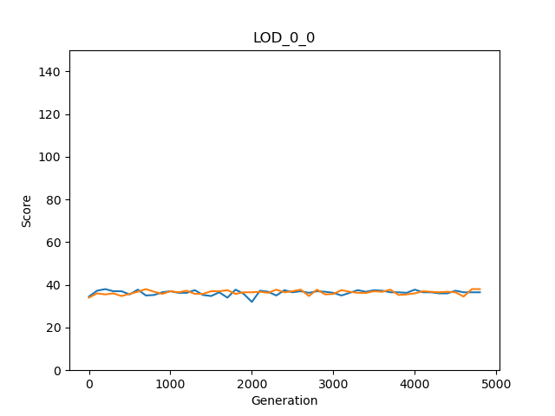Graph test (step 3)

LOD statistics test (step 4)

Step 4.1

Firstly, we have checked if we calculated the minimum, maximum, sum, and average of each row correctly. For this case, we tested two of the rows from LOD\_0\_0\_0 and LOD\_0\_0\_1 manually.

Step 4.2

|  |  |  |  |  |  |
| --- | --- | --- | --- | --- | --- |
| rewardGroupModes | meanOwnScores | meanMinimums | meanMaximums | meanAverages | meanSums |
| LOD\_0\_0 Replicate 0 & 1  (Excel) | 36.41326531 | 25.83673469 | 48.3775510 | 36.413265 | 145.653061 |
| LOD\_0\_0  Replicate 0 & 1  (Python) | 36.41327 | 25.83673 | 48.37755 | 36.41327 | 145.6531 |

### Movement analyzer

Testing:

First, we should make sure that the percentages for each movement file are calculated correctly. For this proposal, we selected two of the files and compared the results using python and excel.

The next testing part is about the averages, which again we compared python and the Excel results.

|  |  |  |  |
| --- | --- | --- | --- |
| Reward scheme and  group mode | Mean of *giving or putting grasses* percentage | Mean of *do nothing*  percentage | Mean of *beep* percentage |
| Movement\_1\_1 Excel | 0.002 | 2.0775 | 21.978 |
| Movement\_1\_1  Python | 0.002 | 2.0775 | 21.978 |
| Movement\_2\_1  Excel | 2.006 | 0.8965 | 21.8615 |
| Movement\_2\_1  Python | 2.006 | 0.8965 | 21.8615 |

### Beep analyzer

# Results

## Score variations through generations (Based on LOD files)

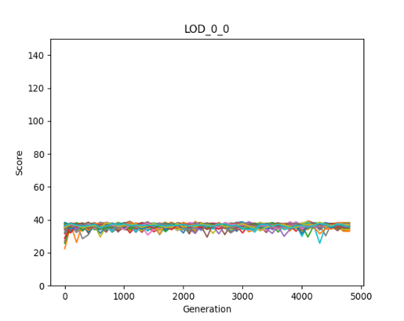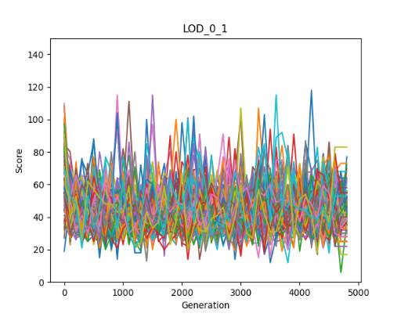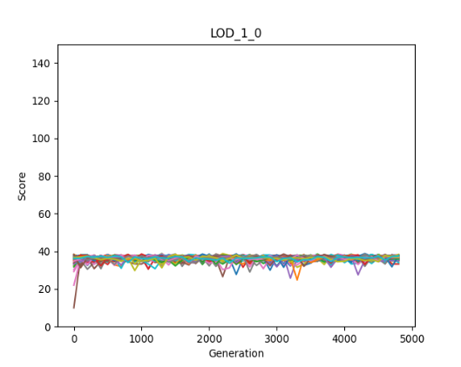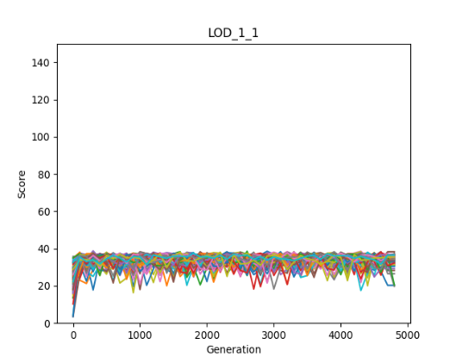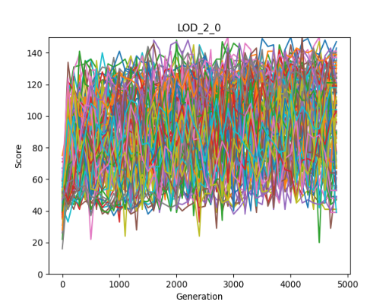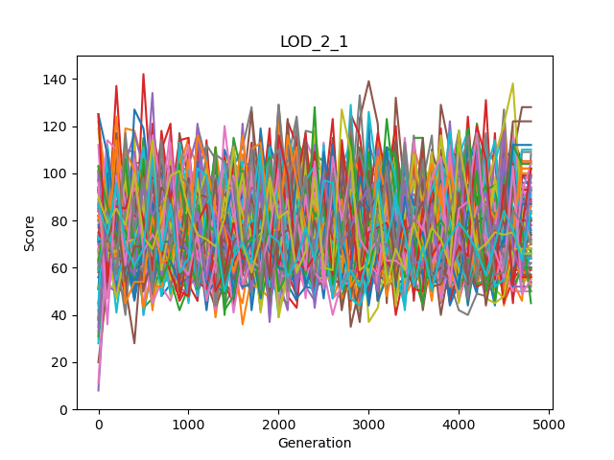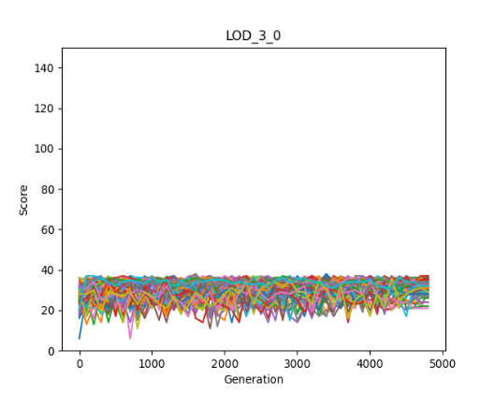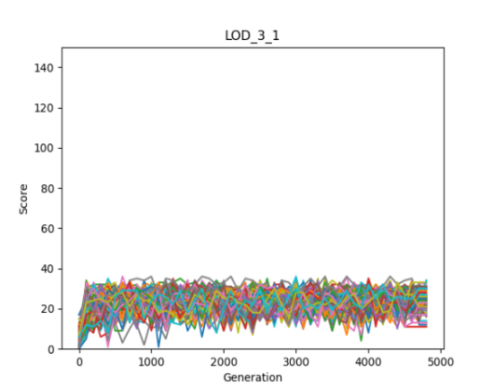

Individual | Clone

Individual | Group

Mean | Clone

Mean | Group

Maximum | Clone

Maximum | Group

Minimum | Clone

Minimum | Group

## Overall score statistics (Based on LOD files)

|  |  |  |  |  |  |
| --- | --- | --- | --- | --- | --- |
| rewardGroupModes | Mean  OwnScores | Mean  Minimums | Mean  Maximums | Mean  Averages | Mean  Sums |
| LOD\_0\_0  Group mode: Clone  Reward mode: Individual | 36.4275510 | A picture containing shape  Description automatically generated26.0175510 | 47.4516326 | 36.4275510 | 145.710204 |
| LOD\_0\_1 3  Group mode: Not Clone  Reward mode: Individual | 44.7497959 | 20.1351020 | 52.0906122 | Logo  Description automatically generated36.5244898 | Logo  Description automatically generated146.097959 |
| LOD\_1\_0 2  Group mode: Clone  Reward mode: Average | 36.4372959 | Logo  Description automatically generated25.8336734 | 47.5702040 | A picture containing shape  Description automatically generated36.4372959 | A picture containing shape  Description automatically generated145.749183 |
| LOD\_1\_1  Group mode: Not clone  Reward mode: Average |  | 11.6457142 | Logo  Description automatically generated56.7748979 | 33.9260204 | 135.704081 |
| LOD\_2\_0  Group mode: Clone  Reward mode: Maximum |  | 2.70897959 | Logo  Description automatically generated91.9987755 | 30.8365306 | 123.346122 |
| LOD\_2\_1  Group mode: Not clone  Reward mode: Maximum |  | 1.56244898 | A picture containing shape  Description automatically generated75.5930612 | 31.0185204 | 124.074081 |
| LOD\_3\_0 1  Group mode: Clone  Reward mode: Minimum | 30.7763265 | Logo  Description automatically generated30.7763265 | 42.3973469 | Logo  Description automatically generated36.4311734 | Logo  Description automatically generated145.724693 |
| LOD\_3\_1  Group mode: Not clone  Reward mode: Minimum | 34.1008163 | 23.0051020 | 44.5406122 | 33.0433673 | 132.173469 |

## Clone versus not clone statistics (Based on LOD files)

Always the minimum scores are higher in clone mode relative to different individuals. So, if we are interested in having good minimum scores, we should use clone mode.

Except for the maximum rewarding scheme, the top score is higher when we have different agents. Therefore, if we do not consider setting a rewarding scheme, various agents are better than clones.

As in the previous graph, except for the maximum rewarding scheme, the own score is higher when the agents are not identical. Therefore, if we do not consider setting a rewarding scheme, different agents have better performance.

There is no clear pattern; however, when clone modes have more significant averages, the differences are more prominent. So, we can say that for average, also the clones are better.

Again, there is no clear pattern, and when clone modes have a bigger sum, the differences are more significant. As the average for total sum also clones are slightly better.

## Behavioral statistics (Based on movement files)

|  |  |  |  |
| --- | --- | --- | --- |
| Reward scheme and  group mode | Mean of *giving or putting grasses* percentage | Mean of *do nothing*  percentage | Mean of *beep* percentage |
| Individual  Clone | 0 | 0.7005 | 13.4225 |
| Individual  Not clone | 0 | 0.136 | 24.147 |
| Average  Clone | 0 | 0.2965 | 17.156 |
| Average  Not clone | 0.002 | 2.0775 | 21.978 |
| Maximum  Clone | 24.948 | 3.304 | 53.814 |
| Maximum  Not clone | 2.006 | 0.8965 | 21.8615 |
| Minimum  Clone | 0 | 0.963 | 51.2315 |
| Minimum  Not clone | 0 | 8.1085 | 9.5385 |

## Beep versus mute statistics (based on beep files)

|  |  |  |  |  |
| --- | --- | --- | --- | --- |
| Reward  And Group | Beep  Mean Minimums | Mute  Mean Minimums | Beep  Mean Maximums | Mute  Mean Maximums |
| Individual  Clone | 26.09 | 25.24 | 47.19 | 46.11 |
| Individual  Not clone | 26.958 | 26.954 | 47.53 | 47.43 |
| Mean  Clone | 26.14 | 25.27 | 47.45 | 46.20 |
| Mean  Not clone | 25.41 | 25.45 | 46.97 | 46.99 |
| Maximum  Clone | 1.56 | 3.74 | 92.88 | 34.00 |
| Maximum  Not clone | 25.13 | 25.57 | 46.89 | 47.41 |
| Minimum  Clone | 31.51 | 8.72 | 41.49 | 15.19 |
| Minimum  Not clone | 23.72 | 23.46 | 43.85 | 43.47 |

|  |  |  |  |  |
| --- | --- | --- | --- | --- |
| Reward  And Group | Beep  Mean Averages | Mute  Mean Averages | Beep  Mean Sums | Mute  Mean Sums |
| Individual  Clone | 36.40 | 35.40 | 145.61 | 141.63 |
| Individual  Not clone | 36.97 | 36.96 | 147.88 | 147.84 |
| Mean  Clone | 36.52 | 35.46 | 146.10 | 141.86 |
| Mean  Not clone | 35.88 | 35.92 | 143.55 | 143.69 |
| Maximum  Clone | 30.00 | 16.24 | 120.03 | 64.97 |
| Maximum  Not clone | 35.75 | 36.21 | 143.03 | 144.87 |
| Minimum  Clone | 36.46 | 11.89 | 145.84 | 47.56 |
| Minimum  Not clone | 33.44 | 33.15 | 133.77 | 132.61 |

# Discussion

# Conclusions

# References

|  |  |
| --- | --- |
| [1] | L. Joel, C. Jeff and M. Dusan, "The surprising creativity of digital evolution," in *Artificial Life Conference Proceedings 14, pages 76-83. MIT Press*, 2017. |
| [2] | H. Arend and M. Masoud, "Evolution of autonomous hierarchy formation and maintenance," in *Artificial Life Conference Proceedings 14, pages 366-367. MIT Press*, 2014. |
| [3] | B. Gergely and S. Szabolcs, "Beneficial laggards: multilevel selection, cooperative polymorphism and division of labour in threshold public good games," *BMC evolutionary biology,* 2010. |
| [4] | B. Clifford and H. Arend, "Mabe (modular agent based evolver): A framework for digital evolution research," in *Artificial Life Conference Proceedings*, 2017. |
| [5] | H. Arend, A. E. Jeffrey, S. O. Randal, B. K. David, S. Jory, A. Larissa, T. S. Ali, K. Peter, S. e. Leigh och G. Heather," Markov brains: A technical introduction". |